Proposal for customer segmentation

Prepared for: Anyfreelancer.com

Prepared by: Customer segmentation group

# Executive summary

We would like to thank Anyfreelancing.com for inviting us to present our proposal for the customer segmentation, recommendation through digitalization initiative, and are happy to present a proposal for this.

We understand that Anyfreelancing.com, current centrally managed their website which is static and lacks personalization for their various types of customers including existing customers, leads, prospects, etc. Thus, to make the online user journeys more engaging and improve the performance of the website, the digital content and navigation flow of the website are envisioned to be personalized with the help of segmentation.

The pursuit to deliver personalized customer experience to Porsche’s existing or potential customers, will need to extend ***beyond the realm of Anyfreelancer.com*** and need to extend to other channels of customer interaction, digital or non-digital. Personalization requires moving to segmentation based approach and to extend a more customized one-on-one treatment for customer based on their unique content and relevance. The sheer volume of choices available to the customer requires self-learning machine learning based algorithms. Only a true Digital Intelligence Platform, can offer amazing personalised omni-channel customer experiences.

# Current State

Anyfreelancing has offered global static content to their all online users worldwide. The users of this website are as bellows -

* Employers – People, who post the work to be done and eventually hires the suited freelancer/s for the job.
* Freelancers – People, who wants to do the work. They bid for desired jobs.

In today’s digital world, where **experiences matter**, the centrally managed Anyfreelancing.com website **lacks any personalization for their registered and unregistered users**. Also, a lot of content is static for all users and overlooks any personalized flavor for the users.

Anyfreelancing marketing team of the business wants to pitch **marketing schemes pertaining to the customer needs**. They do not want to pitch same scheme to every customer because they have realized over time every customer is different and has different needs. But, due to the lack of personalization they are not able to understand their customer needs and requirements.

Hence, we would like to build Customer Segmentation engine, which will help them to understand their customers based on multiple segments approach and if customer lies on any particular segment then marketing team will offer their scheme of their customer needs and requirements.

# Key business drivers

The business drivers are external or internal influences that significantly impact and/or set direction for customization of Anyfreelancing.com website interface based on customer segmentation and Identifying and prioritizing these are the critical first step in creating the blueprint. We have identified the following business drivers for the assignment:

1. **Know the customer better** – It is important to understand the behavior and pinpoint the struggle and trouble areas of a user. This will help to understand the needs of the user over time.
2. **Serve & offer personalized offering** - Provide dynamic content and offering with customization as per user’s behavior and real time analytics on available data to enhance the digital experience.
3. **Enhance user experience & engagement** – Anyfreelancer.com aims to personalize their web interface to improve the user engagement and build trusted relationships with its customers through segmentation, analytics and experience.
4. **Increase conversion rate (onsite & offsite)** – The ultimate goal of creating a high-end intelligent interface is to improve the conversion rate through onsite and offsite channel by creating appropriate offering.

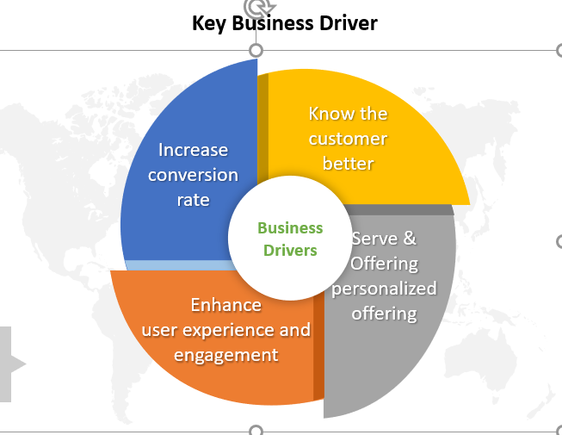

Based on above key drivers, we suggest that this new customer segmentation-based platform, will help them in following areas.

* This will **help in effective marketing of the business** and thereby will help in business revenue.
* This will **save cost for the business** as some age-old marketing methods can be avoided.

# Competitive analysis

As a part of competitive analysis, we have identified that there are following 5 customers which are leading in the freelancing industries and identified their SWOT analysis and current offering.

* Upwork
* Fiverr
* Internshala
* Guru.com
* Freelancer

## Upwork:

* Upwork’s strengths are its easy-to-browse freelancer profiles, money-back guarantee, payroll services, and Work Diary that shows screenshots taken at 10-minute intervals.
* [Upwork](https://blog.hubstaff.com/upwork-time-tracker/) is a popular freelancing site that allows you to hire, manage, and pay freelancers from around the world.
* Freelancers from this platform are flexible and can operate on projects that are short, ongoing, individual, team-based, and more. It’s the perfect option for many freelancers, especially ones in the early years of their freelancing careers.
* As a business owner, the site is very easy to use and has everything you need to hire a freelancer right away. Just post a job, hire your freelancers, track their work hours and then pay them by linking your credit card, bank account or PayPal. All of this is done via Upwork to make it easy to focus on your project instead of logistics.
* Upwork connects businesses of all sizes to freelancers, independent professionals, and agencies for all their hiring needs. Scale your workforce dynamically as business needs change.

What are the points they have segmented the customers:

1. Skills
2. Brief about the work experience
3. How much they are taking per hrs
4. Rated each of customer as per client experience
5. Location
6. How much amount they have earned till this time
7. Language

It saves the organic marketing.

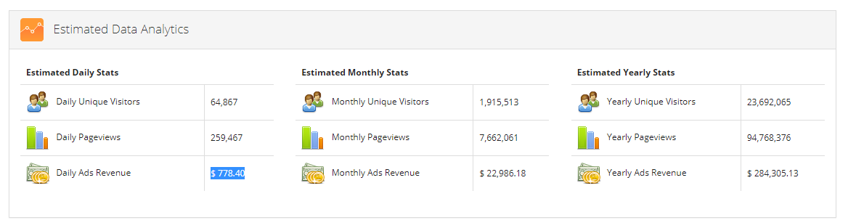

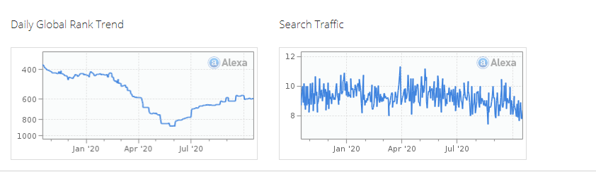

## Fiverr:

This website has segmented in such way the customer should create a profile in such way that why a particular candidate is suitable for it work and why to choose them like what are the skill they have.

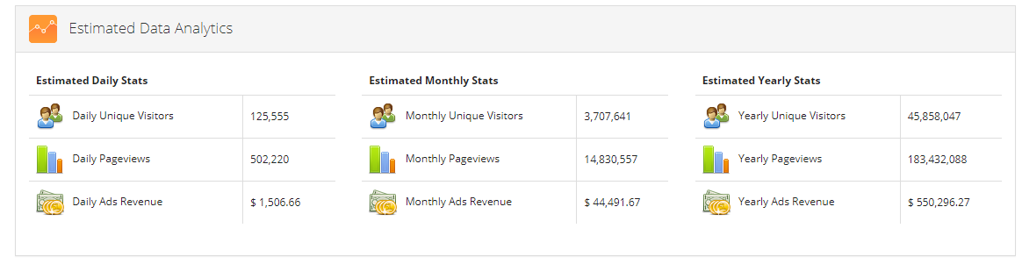

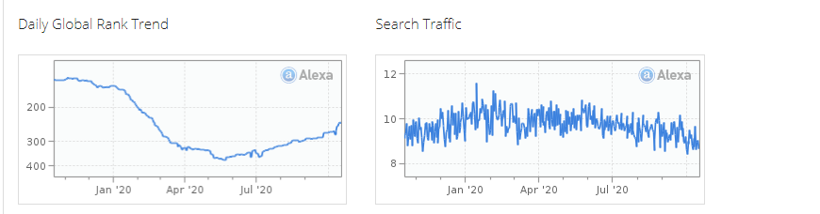

## 3 .Internshala

Internshala is India's no.1 internship and training platform with 40000+ paid internships in Engineering, MBA, media, law, arts, and other streams and they are using customer segmentation approach to boost their business.

* Skills
* location
* categories
* maximum duration
* Starting date
* Gender

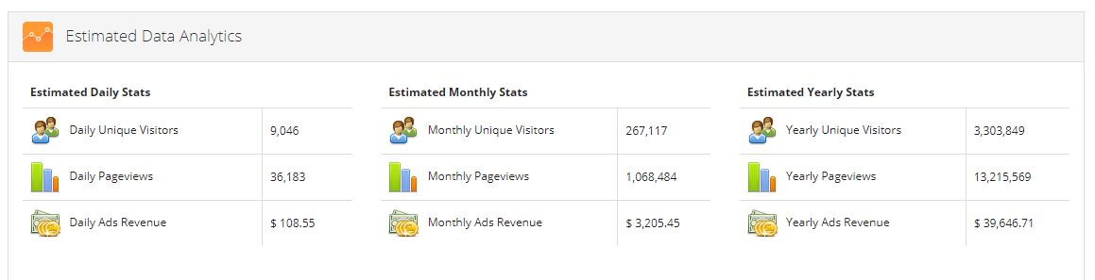

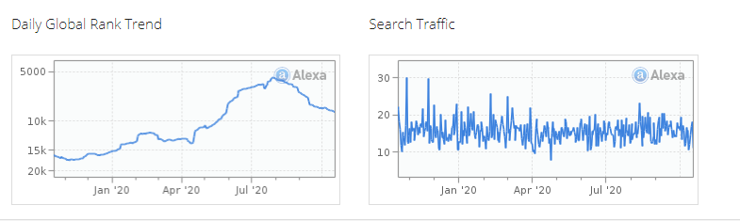

## 4.Guru.com

Guru is a freelance service based in Pittsburgh, PA, that helps businesses find the right freelancers for the right job. They have a global network of more than 1.5 million “gurus” who can help with your technical, creative, and business projects. In order to find freelancers with Guru, just post a project for free. You can browse freelancer profiles and view past work so you can hire your freelancer with confidence. Once you have chosen a freelancer, manage your project online at the Guru Workroom, where you can create agreements, define milestones, assign tasks, communicate, share documents and more. Guru also takes care of payments; you pay Guru and they will release the funds to your freelancer only when you approve the work. They are also using customer segmentation approach based on below segmentation category.

* -domain
* -selecting subcategories of the domain
* -Location
* -total earning
* -member since
* -skill & Expertise

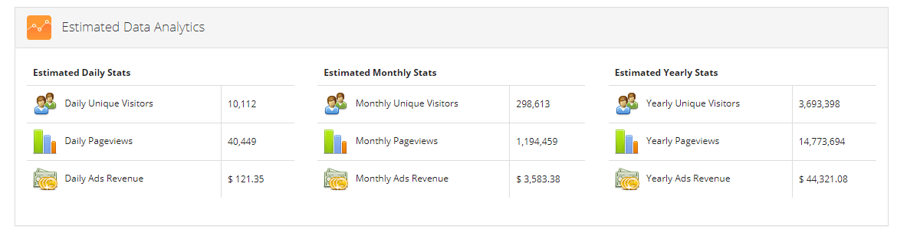

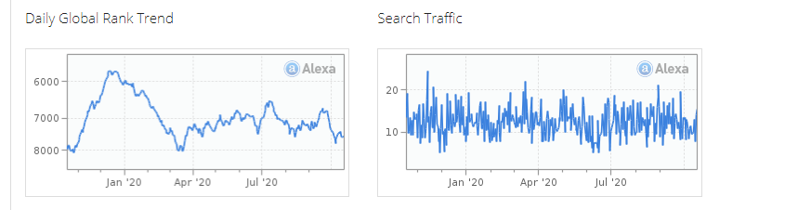

## 5. Freelancer.com

[Freelancer](https://blog.hubstaff.com/finding-clients-on-freelancer-com/) is the world’s largest freelancing, outsourcing, and crowdsourcing marketplace. Their extensive network of employers and freelancers spans 247 countries, regions and territories, and they have hosted more than seven million projects since 2001.

In order to find a qualified freelancer for your job, just post a project and receive bids within minutes. Then compare proposals and price, select the freelancer you want to work with, and begin work. Freelancer provides communication tools and secure payment services. Freelancer will only release your payment when you are satisfied with the work provided by their freelancers. They are also using customer segmentation approach based on below category.

* -skills
* -language
* -expertise’s

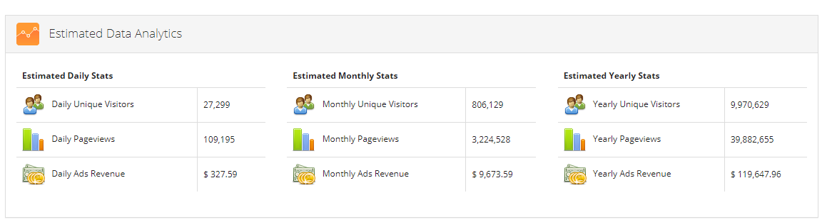

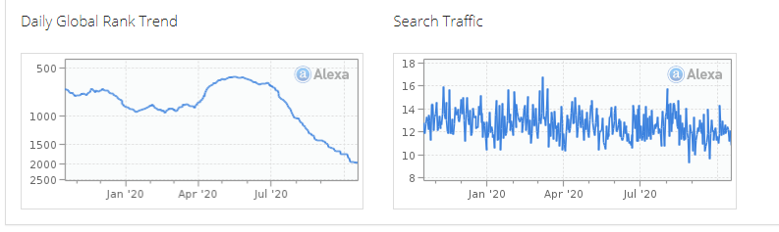

# Business challenges

We would like to highlight that, if any company is not practicing customer segmentation approach to server their end users and customers. They might feel such kind of challenges.

* Fail to Provide Enough Actionable Detail.

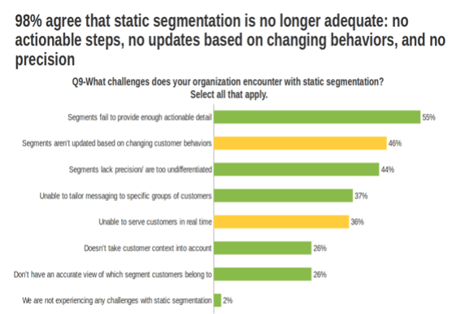

* Aren’t Updated Based on Changing Customer Behaviors
  + lack of ability to be updated based on changing customer behavior.
* Lack Precision & Are Too Undifferentiated
  + simply never be able to capture the precision, granularity, and dynamism of real customer life.
* Unable to Tailor Messaging to Specific Groups of Customers
  + a major issue is the lack of capacity to tailor messaging and outreach to groups of customers.
* Lack of Transparency Loses Customer Context

# Revenue Model

As a part of this competitive research we have identified that currently top 5 organizations are using following pricing models.

## Transactional model

For every transaction, the marketplace takes a cut of each transaction generated through the platform. It also tends to scale well, the more sales it generates, the more revenue it gets generated. The company charges a service fee for successfully matching buyers, sellers, hosts, guests & borrowers. The fee usually varies from 5% to 40% depending on the value of the transaction and the services provided.

## Lead-Based model

In this model, professionals usually send quotes to customers. Based on the specific needs of the project the platform facilitates the interaction between the customers and the professionals. Professionals who are interested and available, make bids for customers to choose from. Customers can Sign up to the platform for free, however, the company charges professionals to send quotes to customers.

## Subscription model

As per the above two revenue model this is also similar to other subscription methods, customers are billed on a recurring basis and receive their services at the same time every month or as per their convenience. The benefit in this model is that once a customer signs up, there are high chances that they will stick around. Generally, the company offers a range of subscription plans at different prices based on the frequency of use and the number of goods desired.So, based on above revenue generation model, we think transaction model is the main source of revenue. So, if we can increase the transactions happening on a freelance website then it will directly increase the Revenue of the business.

Employer is the one who is going to make the payment through transactions so if we can increase the number of employers in our application OR we can give customized offers to the existing Employers then it will definitely increase the transactions and thereby having a significant impact on Business Revenue

# Benefits of customer segmentation- We are thinking that if Anyfreelancing.com will use this customer segmentation approach then they will get following benefits.

* Segmentation is a strategic asset.
* Marketing to today’s customers is all about context.
* Marketers need to engage customers by providing highly relevant content and personalized experiences.
* A customer segmentation model allows for the effective allocation of marketing resources and the maximization of [cross](https://searchcustomerexperience.techtarget.com/definition/cross-sell)- and [up-selling](https://searchcustomerexperience.techtarget.com/definition/up-sell) opportunities.
* Reporting based on various stats
* More customer retention
* Enhances Competitiveness
* Establishes Brand Identity
* Better Customer Relationship
* leads to price Optimization
* Improves the channel of distribution

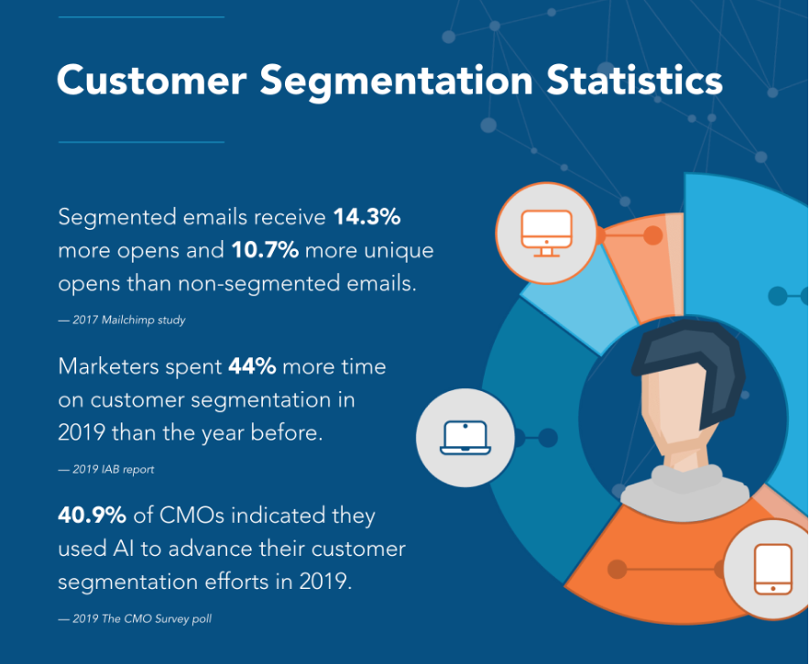

There are several reports which we can help marketing managers to verify their goal and prospects strategy and this will help them a lot to know about customer prospects based on segmentation reports.

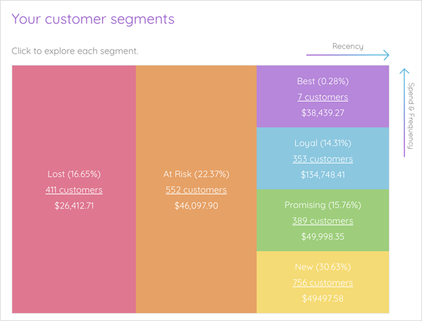

Illustration of Customer Segmentation

For illustration and just to give you a feel of customer segmentation we can segment the customers based on –

Demographic Customer Segmentation  – Basing your segmentation on demographics allows you to target customers by age, location, gender, income level, and so much more. This is the most popular way to segment customers.

Psychographic Customer Segmentation – For social media advertising you can [leverage psychographic data](https://www.oberlo.com/blog/psychographics) to segment your customers by their opinions, behaviors, and attitudes. As this information is a bit harder to discover there are very few places that you can glean this information from.

User Engagement Customer Segmentation – Segmenting your customer by how they interact with your website or marketing material can be a great way to increase conversions through sales and marketing. Customers who repeatedly buy from you could fall into the loyal customer segment and receive discounts on purchases.

### Goal Customer Segmentation– Your company could offer many things online, like a webinar, a free trial, and an email subscription. Not all visitors to your website will want all these things. That is why it is a good idea to segment customers [based on their intent on your website](https://postfunnel.com/3-customer-segmentation-models-every-marketer-consider/). You may know that webinar sign-ups are more likely to convert into customers than those who do not attend the webinar. Realistically you should be presenting different information to these two groups.